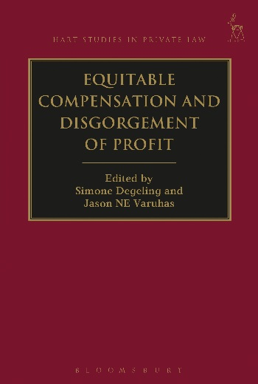
Equitable Compensation and Disgorgement of Profit
Edited by Simone Degeling and Jason NE Varuhas

This collection of essays interrogates significant issues at the forefront of scholarship and legal practice in the field of money remedies in equity. Chapters address the contentious and developing field of equitable compensation, including: the nature of equitable compensation; the relevant causation inquiry for equitable compensation; whether notions of contribution apply to multiple agents; accessorial liability; the role of discretion in limiting equitable compensation; which wrongs yield equitable compensation; and the extent to which compensation in equity differs from money remedies at common law. Other chapters examine the remedy of disgorgement of profit, and specifically the theoretical basis of that remedy, its application in the context of fiduciary obligations, and third-party issues. A number of chapters also examine the interrelationship between loss- and gain-based money relief.
In addressing these issues the book includes both doctrinal and theoretical perspectives, and brings together leading equity scholars and judges from across the common law world.

Simone Degeling is Professor of Private Law in the University of New South Wales.
Jason NE Varuhas is Associate Professor, University of Melbourne.

April 2017 | 9781509901456 | 376pp | Hardback | RSP: £80
Discount Price: £64

Click here to order online and use the discount code ODG at the checkout to get your 20% off

